**Intro Material**

1. List the 6 areas of Biopsychology and aspects unique to each one. Try to think of research questions that would fall under each category.

|  |  |  |  |
| --- | --- | --- | --- |
| **Area** | **Unique Aspects** | **Match below** | **Create your own research questions in groups** |
|  |  |  |  |
|  |  |  |  |
|  |  |  |  |
|  |  |  |  |
|  |  |  |  |
|  |  |  |  |

1. Match the following questions with the appropriate field of Biopsych in the chart above:
2. How do emotion regulation strategies alter brain activity?
3. Do humans and insects share genes related to sociability?
4. How do opioids effect pain receptors in the brain?
5. Can stimulation of the motor cortex (posterior precentral gyrus) cause involuntary movement?
6. What cardiovascular changes take place during a stressor task?
7. What are the behavioral changes associated with damage to the prefrontal cortex?
8. Define convergent evidence and be able to give examples we talked about in class when convergent evidence was absent.

**Neuron Structure**

1. Label the neuron below using the following terms (also be able to define these terms and explain their functions):

Myelin-

Soma-

Dendrite-

Axon-

Axon Terminal-

Axon Hillock (not pictured)-

1. Identify what types of neurons are depicted and where they are found in the body.

**Glial Cells and Myelin**

1. Fill out the glial cell chart below (do not need to specify the location of microglia).

|  |  |  |
| --- | --- | --- |
| **Glial Cell Type** | **Location** | **Function** |
|  |  |  |
|  |  |  |
|  |  |  |
|  |  |  |

1. Fill out the definitions of these other key terms related to myelin.

Saltatory conduction-

Local Potential-

Nodes of Ranvier-

Myelin-

1. List some of the general benefits of myelin

**Membrane Potential**

1. Draw the forces of diffusion and electrostatic pressure acting on the cell below. Show which ions are inside and outside of the cell and what the charge of the inside of the cell is.

**Action Potential**

1. Fill in the blanks of the Action potential diagram below.

1. Identify the depolarization, repolarization, and hyperpolarization periods in the diagram below. Be able to identify the relative and absolute refractory periods and describe how refractory periods prevent the AP from moving backwards.

**Types of Synapses**

1. Fill out the diagrams below. Identify which diagram depicts an electrical synapse and which depicts a chemical synapse. Be able to describe the differences between the two.

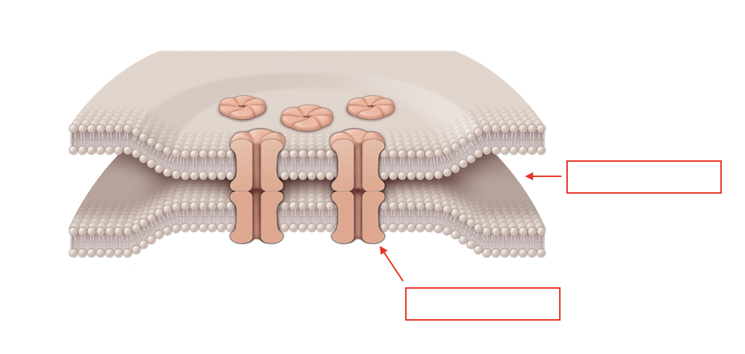

**Practice Questions Pulled from Text**

1. Localization means that
   1. specific functions are found in specific parts of the brain
   2. the most sophisticated functions are located in the highest parts of the brain
   3. any part of the brain can take over other functions after damage
   4. brain functions are located in widespread networks
2. The rate law
   1. explains how the intensity of stimuli is represented
   2. does not apply to neurons outside the brain
   3. describes the transmission in myelinated axons
   4. describes the process of postsynaptic integration
3. There is a limit to how rapidly a neuron can produce an action potential. This is due to
   1. inhibition
   2. facilitation
   3. the absolute refractory period
   4. the relative refractory period
4. An inhibitory neurotransmitter causes the inside of the post-synaptic neuron to become
   1. more positive
   2. more negative
   3. more depolarized
   4. neutral in charge